|  |  |
| --- | --- |
| **Project Case** |  |
| COMP7094 | COMP7094001  Multimedia Programming Foundation |
| **Computer Science** | **E252-COMP7094-RU01-00** |
| ***Valid on*** *Even Semester Year 2024/2025* | **Revision 00** |

1. Kelompok tidak diperkenankan untuk:

*Members of the group are prohibited from:*

* + - Melihat sebagian atau seluruh jawaban kelompok lain,

*Seeing a part or the whole answer from other groups,*

* + - Menyadur sebagian atau seluruh jawaban dari buku, catatan, video, dan jenis referensi lainnya,

*Retell a part or the whole answer from books, notes, videos, and other references,*

* + - Menyadur sebagian atau seluruh jawaban dari internet,

*Retell a part or the whole answer from the internet,*

* + - Mengumpulkan jawaban yang tidak sesuai dengan tema soal,

*Submitting an answer with a different theme from the given case,*

* + - Melakukan tindakan yang menyebabkan jawaban dicontek oleh orang lain atau kelompok lain, baik disengaja maupun tidak disengaja,

*Doing action that could result the answer being copied by someone or other groups, intentionally or unintentionally,*

* + - Melakukan tindakan kecurangan lainnya.

*Committing other dishonest actions.*

1. Jika kelompok terbukti melakukan tindakan seperti yang dicantumkan pada butir ke-1, maka nilai mahasiswa dan/atau kelompok yang melakukan kecurangan, baik menyontek atau dicontek, akan dinolkan sesuai dengan peraturan yang berlaku.

*If it has been proven that a group has committed dishonest actions outlined in point 1 above, the whole groups related to the incident, regardless of which one copies or has their answer copied, will be issued a score of zero according to the regulation.*

1. Jawaban yang dapat diterima dan dinilai adalah jawaban yang dikumpulkan sebelum batas waktu yang telah ditentukan.

*The answer must be submitted before the designated deadline to be accepted and graded,*

1. Jawaban akan dinilai berdasarkan teknik atau metode yang diajarkan pada kelas praktikum dengan menggunakan software yang sudah ditentukan.

*The scoring will be based on the materials taught during the practicum classes using the designated software. Using different software than requested may result in your answer not being graded.*

1. Jika Anda tidak membaca peraturan ini, maka Anda dianggap sudah membaca dan menyetujuinya.

*By taking this exam, you agree to these regulations, regardless of whether you have read it or not.*

1. Persentase penilaian untuk matakuliah ini adalah sebagai berikut:

*The score will be distributed as follows:*

|  |  |  |
| --- | --- | --- |
| **Tugas Mandiri**  *Assignment* | **Proyek**  *Project* | **UAP**  *Final Exam* |
| 40% | 60% | - |

1. Perangkat lunak yang digunakan pada matakuliah ini adalah sebagai berikut:

*This course uses the following software:*

|  |
| --- |
| **Software**  *Software* |
| Eclipse 2024.12 R  Java 11.0.18  JavaFX 17.0.7 |

1. Ekstensi file yang harus dikumpulkan untuk matakuliah ini adalah sebagai berikut:

*Your answers must be in the following file extensions:*

|  |  |  |
| --- | --- | --- |
| **Tugas Mandiri**  *Assignment* | **Proyek**  *Project* | **UAP**  *Final Exam* |
| JAVA, CLASS | JAVA, CLASS, Asset File | - |

1. File yang harus dikumpulkan adalah keseluruhan jawaban beserta dengan aset yang digunakan (gambar, audio, video, dll) dan dokumentasi proyek yang berisikan link referensi aset dan penjelasan mengenai aplikasi yang dibuat (terlampir bersama dengan soal).

*Include other files that can support your project, such as: all files in your project, other files (image, audio, video, etc.) used in your project, *.doc file (documentation of your project) that contains all pages in your project, reference links of additional files (image, audio, video, etc.) used in your project, the description about how to use your application, etc.*

## Soal

*Case*

**RUindows**

Once upon a midnight dreary, you sat all alone by your laptop, when a sudden “*ding!*” echoes your room. An email. It was from an anonymous sender. Against your better judgement, you open the email, “*Greetings, I represent an entity interested with the service you provide. I would like you to design us the user interface of an operating system we are currently building, the total payment for your work will be $100,000.00, 20% paid upfront, and the rest when the work is done. If you decline this offer, do not respond, however, if you do accept, reply this email with a yes within the next 10 hours, the clock is ticking.*”

Clouded by curiosity and greed, you ditched any form of rational thought you would have form and sent a one-worded reply, “*Yes.*” Immediately, another “*ding!*” echoes your room, however, this time from your phone, “*You have received $20,000 from an anonymous user.*” It was from the bank. “*Ding!*” Another email. “*Welcome to RUindows, if you are to reject this offer now, you may not live to see another day, please refrain from discussing regarding this project from anyone else. The rest of your payment will be delivered once the job is done. Good luck and do not disappoint us.*”

Below the latest email, is an attachment for the requirements of the project,

You are to create this design prototype using **JavaFX** as the programming language. Please refrain from using **regex, Java FXML, JavaFX Scene Builder, or any library outside the given materials** during the making of this prototype.

1. **Login Page**

This is the first form that will appear when the program is run. This login form is used by users to access the main applications.

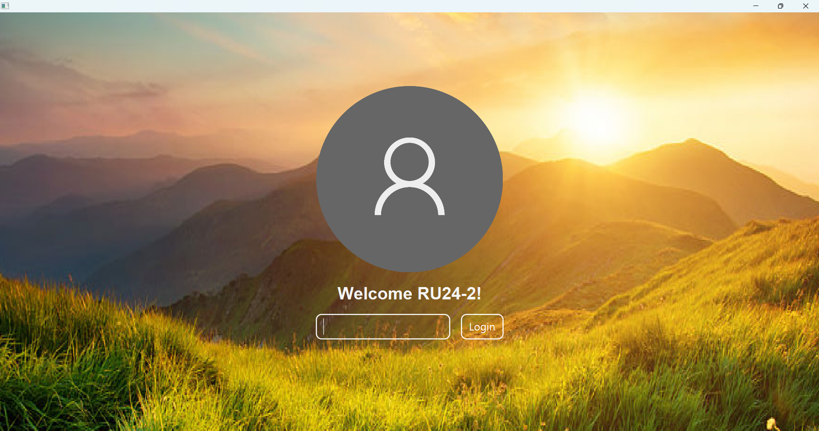

**Figure 1. Login Page**

***Components:***

* **ImageView** for the background image (**nature.png**) and the default profile picture (**default-profile-pic.png**).
* **Label** for the welcome message and wrong password message
* **PasswordField** for the password
* **Button** for the Login button

***Description:***

* If the user clicks the **Login button**,
  + Validate that the password in the **PasswordField** is correct (compare it with a statically defined password).

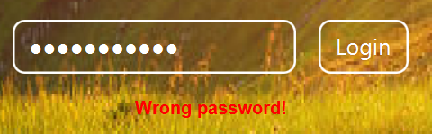

***Figure 2. Wrong Password***

* + If the password is incorrect, display a **Wrong Password** message.
  + If the password is correct, redirect the user to the home page.

1. **Home Page**

This is the page where users can perform certain actions, such as opening applications.

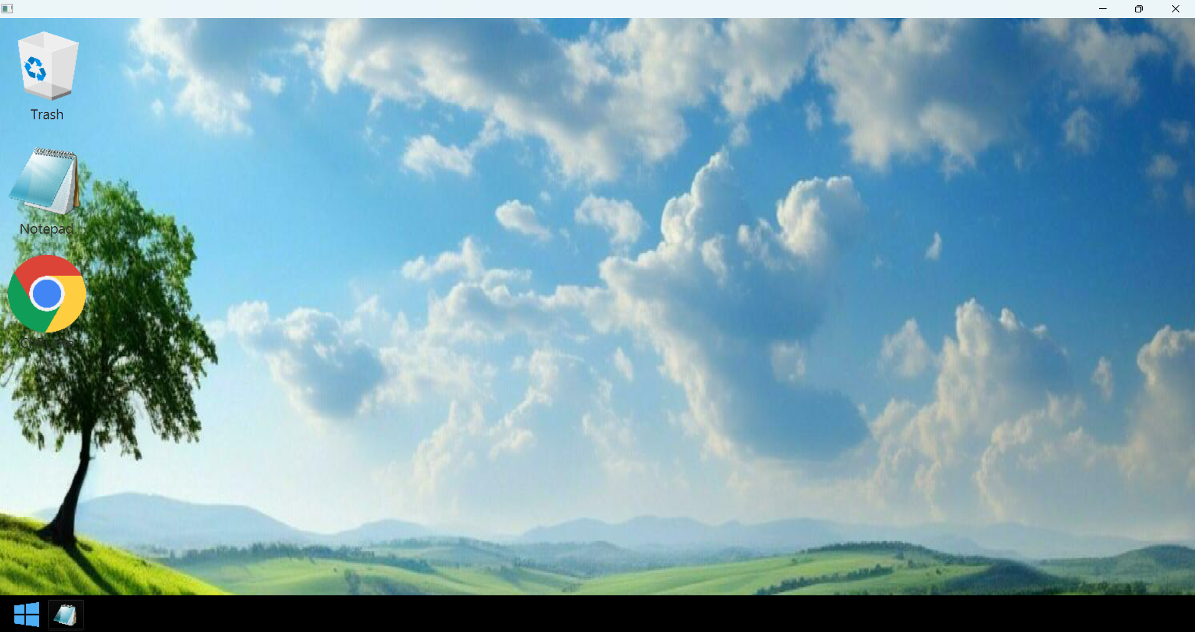

***Figure 3. Home Page***

***Components:***

* **ImageView** for the background image and shortcut icons.
* **Label** for the shortcut titles/names.
* **MenuBar** for the Task Bar.
* **Menu** for the Task Bar icons.
* **MenuItems** for the log out and shutdown menu items.

***Description:***

* The three **shortcuts** you see on the **home page** when the user first runs the program are statically defined.
  + These are the only **shortcuts** that will always show up when the user first runs the program and logins, however this is not the case if the user logs out and logs back in within the same instance of the program running.
  + When these **shortcuts** are opened, they will open the corresponding **applications**.
  + These **shortcuts** are the **Trash**, **Notepad**, and **ChRUme**.
* The task bar will have the two icons, the **Window** icon and the **Notepad** icon.



***Figure 4 Task Bar***

* + The **Window** icon (**window-icon.png**) will open a set of **MenuItems** for logging out and shutting the application down

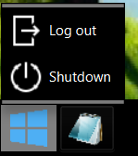

***Figure 5. Log out and Shutdown MenuItem***

These **MenuItems** will have the images **logout3-icon.png** for the **Log out** menu and **shutdown4-icon.png** for the **Shutdown** menu.

* + If the user selects the **Log out** menu, then the user will be redirected to the **Login Page.**
  + If the user selects the **Shutdown** menu, then the program will close/terminate.
  + The **Notepad** icon (**notepad-icon.png**) when pressed will open the **notepad application**.
* If there are more than 5 **shortcuts** within one column, then the newest **shortcut** will be added to the right of the current column.

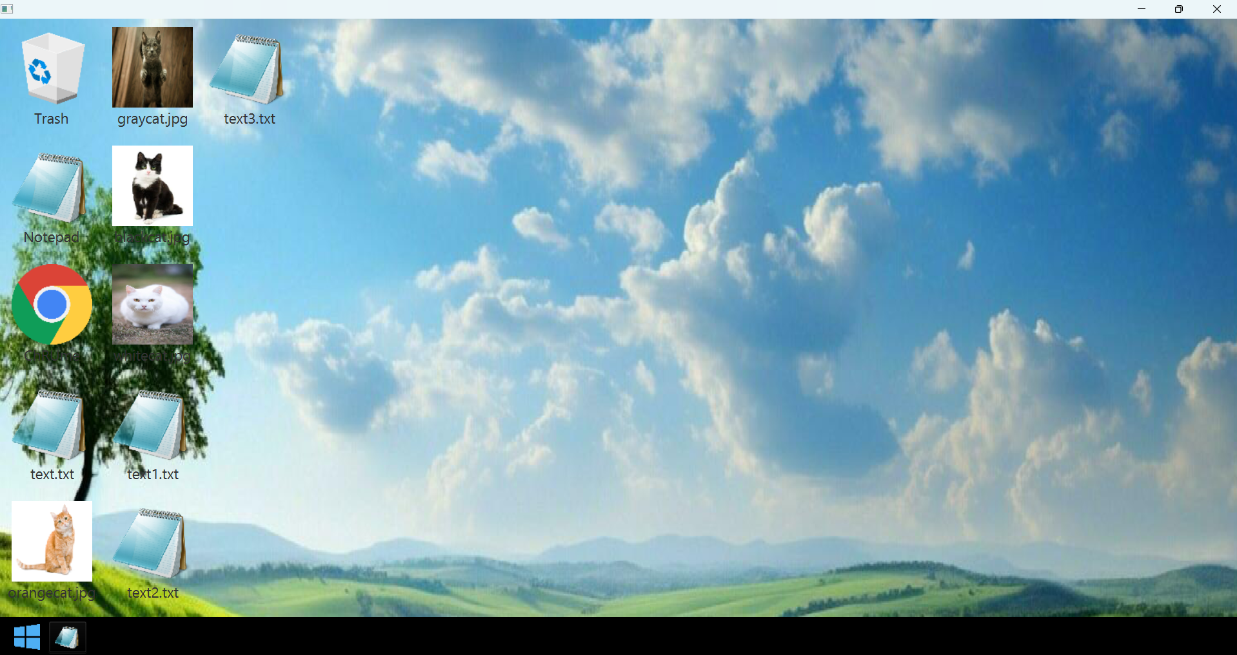

***Figure 6. Shortcut Format on the Home Page***

1. **Notepad Application**

An instance of this application can be opened by clicking the **Notepad** **shortcut** or the **Notepad Menu** in the **Task Bar**.

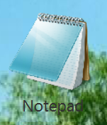

***Figure 7-8. The Notepad shortcut and Notepad Menu***

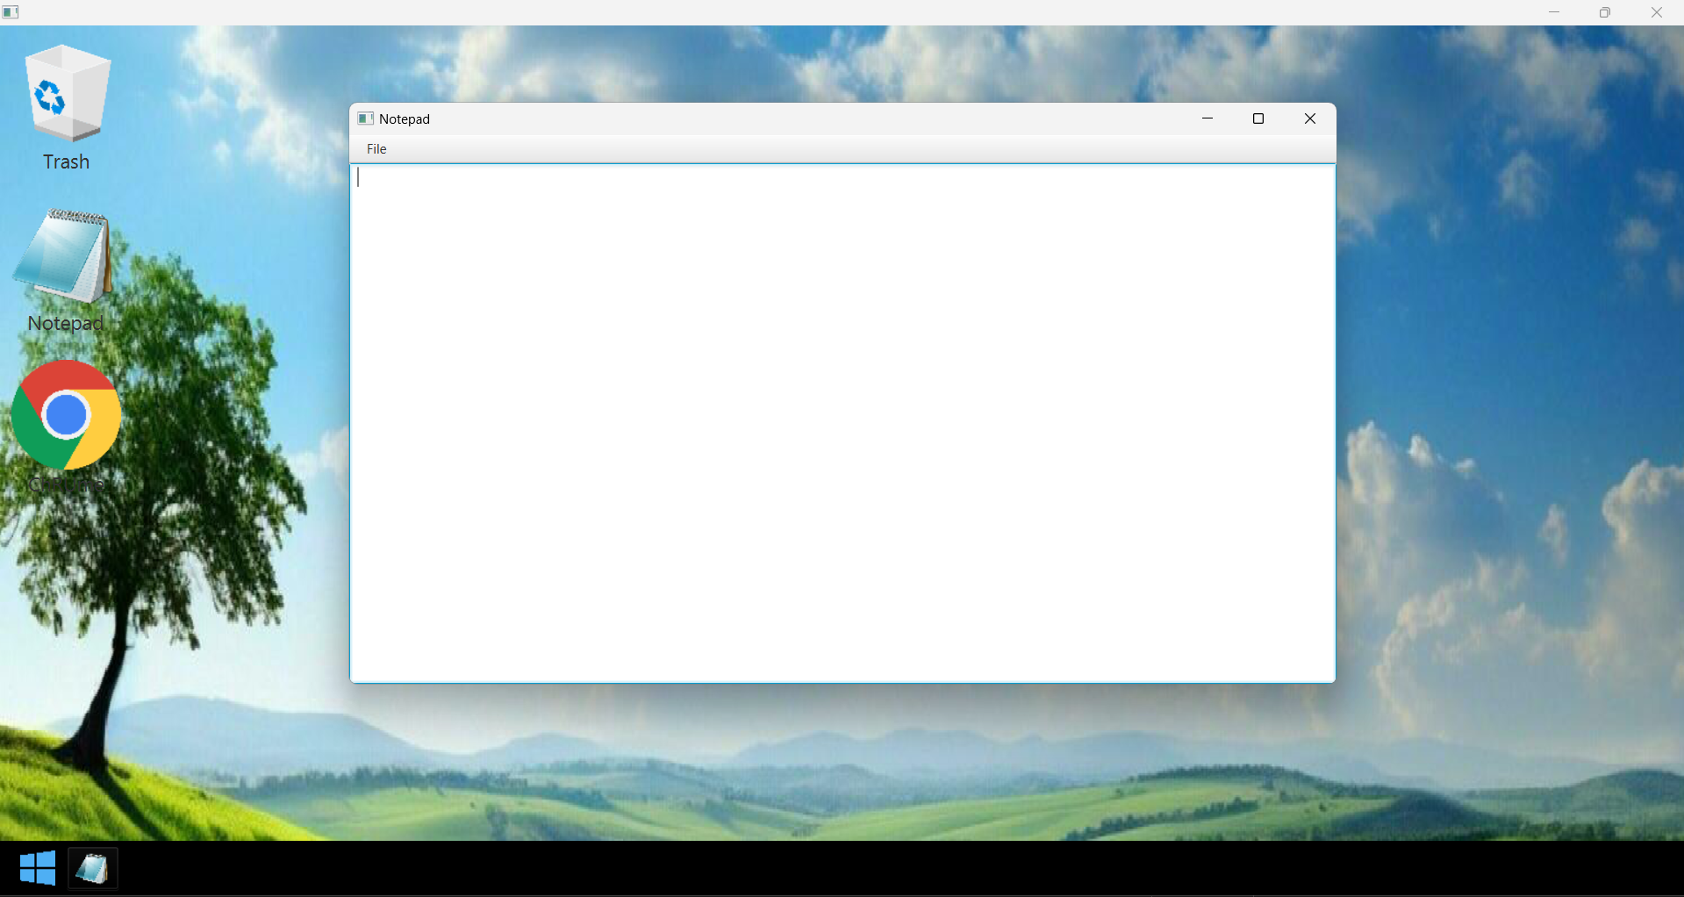

***Figure 9. Notepad Application Instance***

***Components:***

* **ImageView** for the shortcut icon and the icon in the **Task Bar** (**notepad-icon.png**)
* **Label** for the shortcut title/name
* **MenuBar** for the menus on the application
* **Menu** for the **File** menu on the application
* **MenuItem** for the **Save** option on the application
* **TextArea** for the content of the application

***Description:***

* When either the **Notepad shortcut** or **Notepad menu** is clicked, then an instance of the **Notepad application** will appear.
* User is allowed to open as many instances of the **Notepad application** as they please without consequences.
* User is allowed type body of texts within the contents of the **Notepad application**.

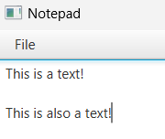

***Figure 10. Body of Texts in the Content of the Notepad Application***

* The **File menu**, when pressed, will reveal a **Save** **MenuItem**, which the user can save their text file using it.

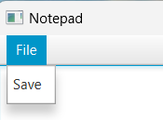

***Figure 11. The File Menu and Save MenuItem***

* + When the **Save** option is pressed, the user will be greeted with the following **TextInputDialog**, prompting them to provide a name for the file.

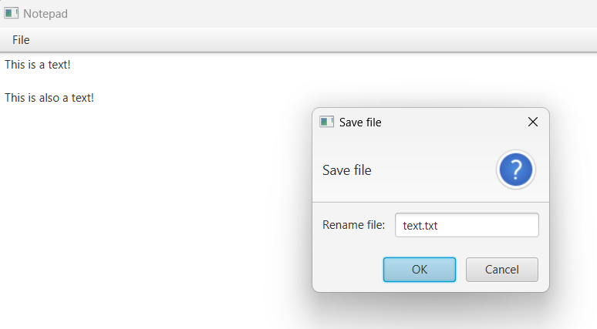

***Figure 12. TextInputDialog Prompting Users to Provide a File Name***

* + - The default text on the **TextInputDialog** uses the following formula,

**text.txt**

**If no other text files have been made previously**

**textN.txt**

Where **N** is the amount of text files currently available or saved minus 1

Example: **text1.txt**, **text2.txt**, **text3.txt**

* + - The user is allowed to change the file name as they please. However, the **file name** to be saved has to satisfy three conditions: **Alphanumeric (not including the .txt extension)**, **Unique**, and **ends with the .txt extension**.
    - If the file name is not **alphanumeric**, then display the following error message.

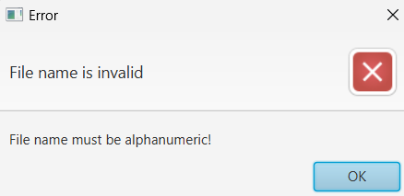

***Figure 13. Alert for a File Name that is non-Alphanumeric***

* + - If the file name is not **unique** (as in a text file with the same name has already existed), then display the following error message.

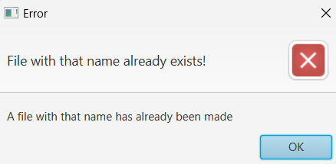

***Figure 14. Alert for a File Name that is not Unique***

* + - If the file name doesn’t have the **.txt** extension in the **TextInputDialog**, then provide the **.txt** extension when saving.
  + When a text file has been saved, a new instance of a **shortcut icon** will appear on the home page. **Note, when a new text file shortcut is added, make sure that it immediately appears in the home page, and without closing the stage.**

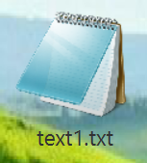

***Figure 15. A Text File Shortcut with the name “text1.txt”***

* + The **text file shortcut** will have an **ImageView** containing the **notepad-icon.png** image and a **Label** with the dedicated file name that the file was saved as (has to end with the **.txt** extension)

1. **ChRUme Application**

**ChRUme** is a web browser application. An instance of this application can be opened by clicking the **ChRUme shortcut** on the **home page**.

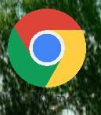

***Figure 16. ChRUme Shortcut***

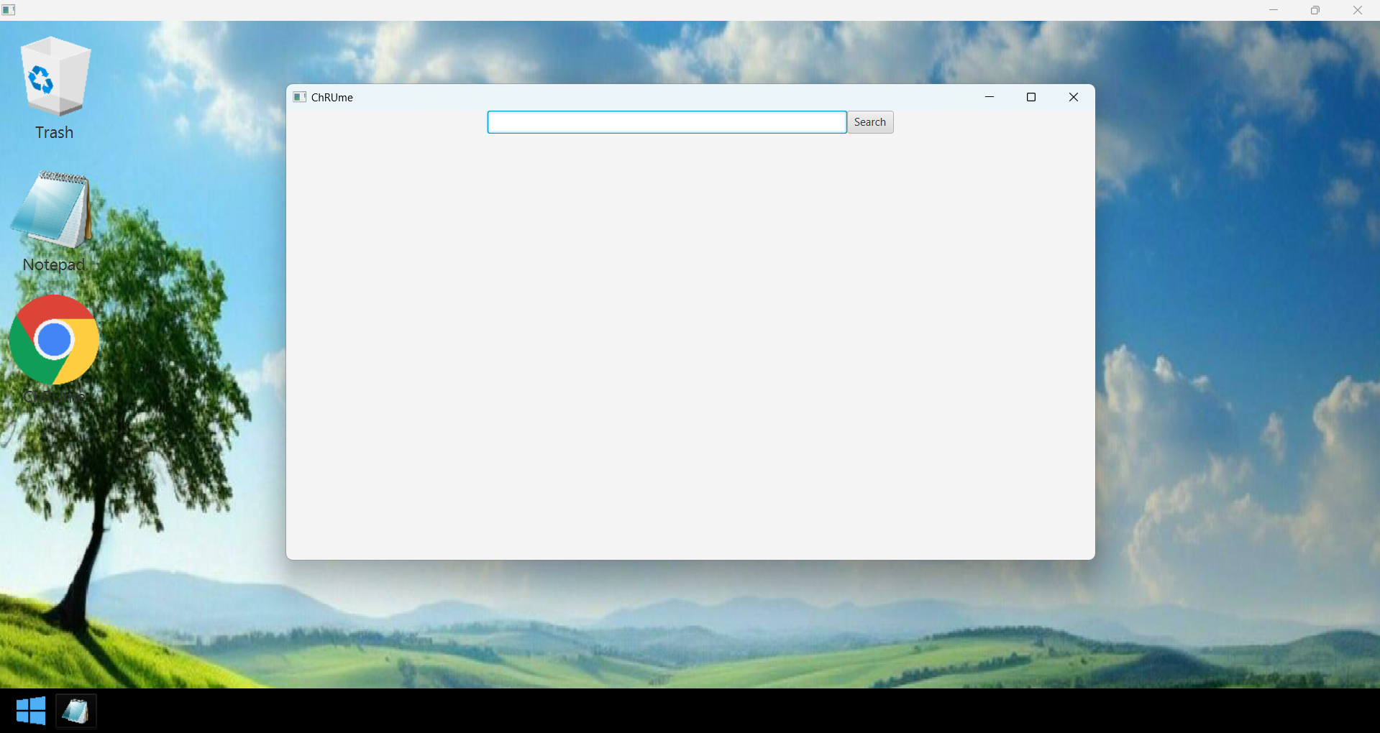

***Figure 17. ChRUme Application***

***Components:***

* **TextField** for the **search bar**.
* **Button** for the **search button**.
* **Panes** for the **websites/content**.

***Description:***

* When the user clicks the **ChRUme shortcut**, a new instance of the **ChRUme application** will appear.
* User is allowed to open as many instances of the **ChRUme application** as they please and without consequences.
* When the user presses enter after typing in the **search bar** or presses the **search button**, a **website** or **content** will be shown corresponding to what was typed in the **search bar**.
* There are a total of 5 different websites/content available on the **ChRUme application** as of now,
  + The **Empty Website/Content** – This website/content will appear if the **search bar** is empty when the user decides to search. This is also the default state when a new instance of the ChRUme application is instantiated.

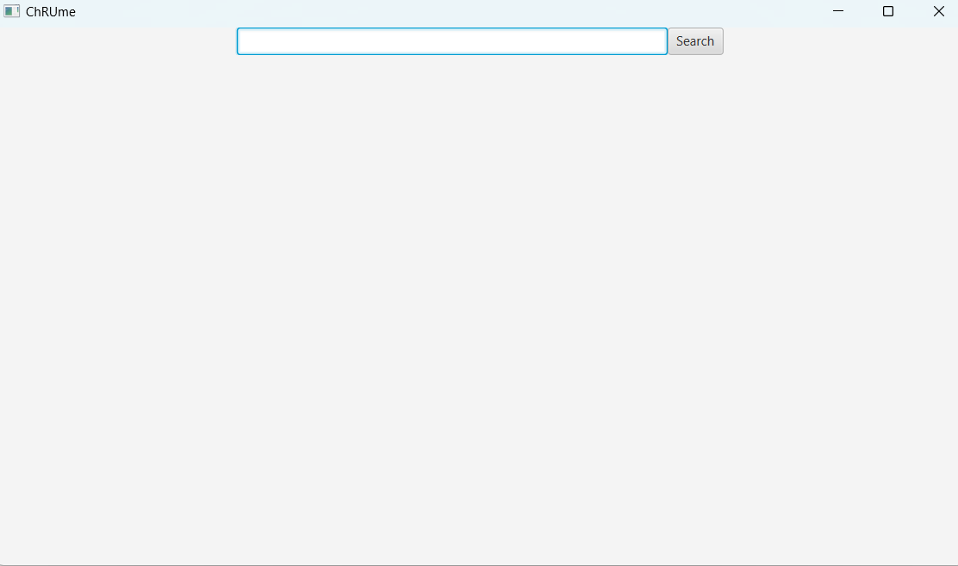

***Figure 18. Empty Website/Content***

* + The **Domain Not Found Content** – This content will appear when the domain searched by the user does not exist within the DNS or database of domain names.

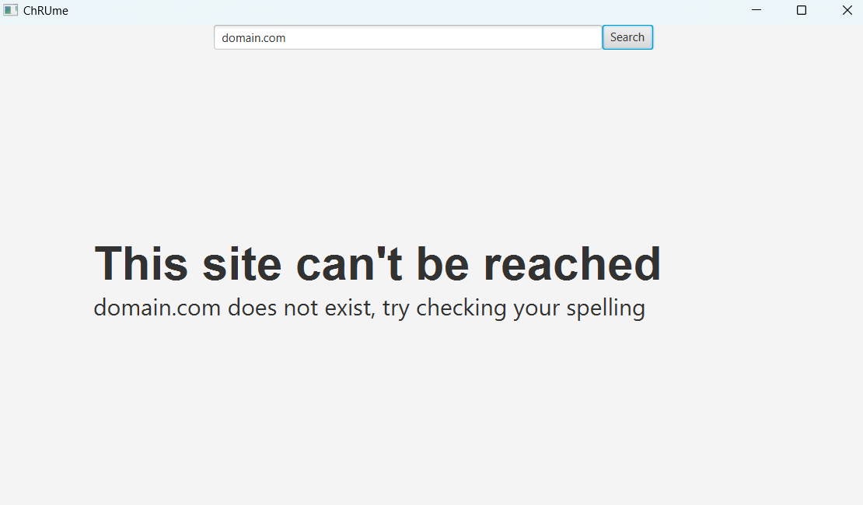

***Figure 19. Domain Not Found Content***

This **domain not found content** has two main components, a **Label** that states “This site can’t be reached” and a **Label** that states that the **domain in the search bar** does not exist.

* + The **RUtube.net Website** – This website will appear when the user types “RUtube.net” (case sensitive) in the **search bar and presses enter** or presses the **search button**.

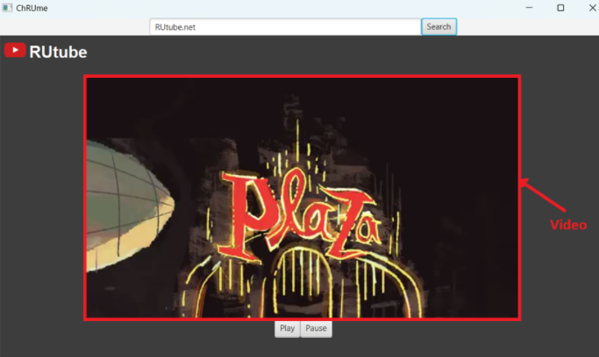  
***Figure 20. RUtube.net Website***

This website will have 3 main components, a **Video** in the center of the screen (**DiamondJack.mp4**), which can be played or paused by pressing the two buttons under it, the **Play** button is for playing the video, and the **Pause** button is for pausing the video.

The rest of the components are the **ImageView** (**youtube-logo.png**) and the **Label** for the logo of the website on the top left.

Note, when the website changes or reloads (the user pressed the search button or enters in the search bar), make sure to **stop the video**. When the instance of the ChRUme application is killed or closed, make sure to **stop the video**, too.

If 2 or more instances of the **ChRUme application** with the **RUtube.net website** opened are instantiated, then each video can and will play separately or **independently** of one another.

* + The **RUtify.net Website** – This website will appear when the user types “RUtify.net” (case sensitive) in the **search bar and presses enter** or presses the **search button**.

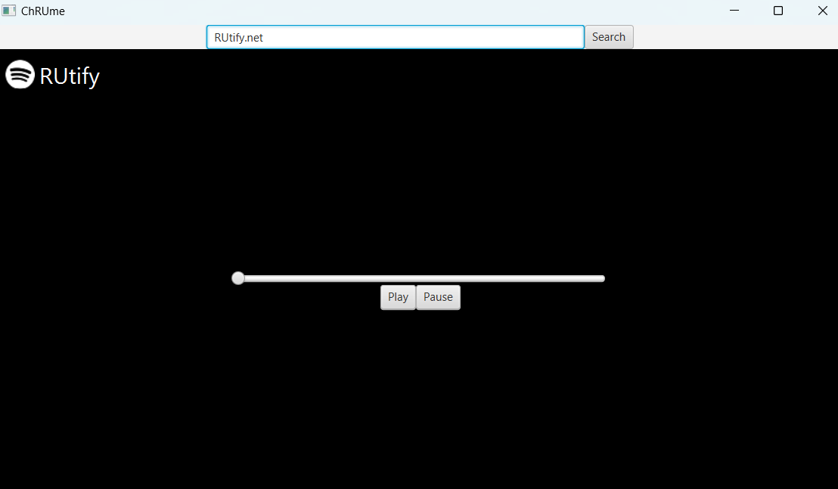

***Figure 21. RUtify.net Website***

This website has 4 main components, an **Audio** (**PromQueen.mp3**), which will play and/or pause when one of the buttons underneath the **slider** is pressed, the **Play** button is for playing the audio, and the **Pause** button is for pausing the audio. The last main component is the **slider** in the center, this slider corresponds to the length of the audio being played. **Note, the user does not need to be able to interact with this slider, example, if the user drags the slider to a certain spot, the audio does not need to be fast forwarded or rewound.**

The rest of the components are the **ImageView** (**spotify-logo.png**) and the **Label** on the top left for the logo of the website.

Note, when the user changes website or reloads the website (the user pressed the search button or enters in the search bar), then the **audio stops**. When the ChRUme instance is killed or closed, make sure to **stop the audio**, too.

If 2 or more instances of the **ChRUme application** with the **RUtify.net website** opened is instantiated, then each audio will play separately or **independently** of one another.

* + The **stockimages.net Website** – This website will appear when the user types “stockimages.net” (case sensitive) in the **search bar and presses enter** or presses the **search button**.

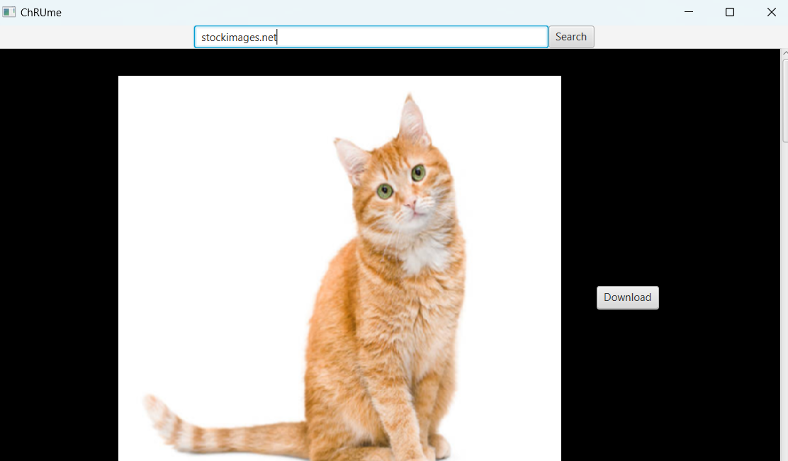

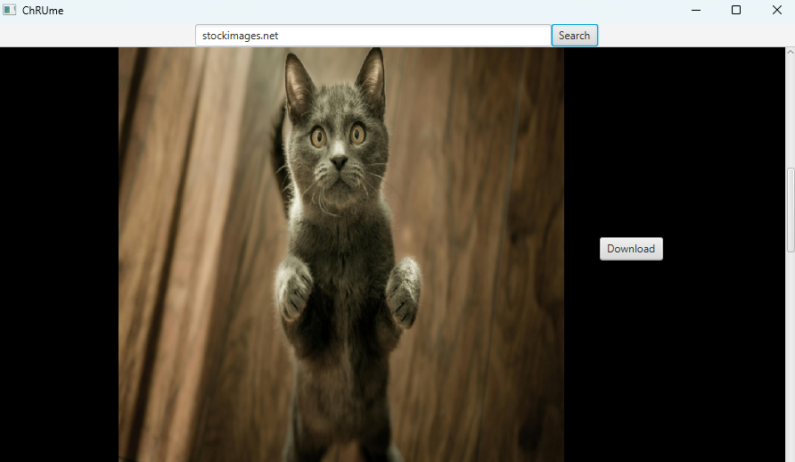

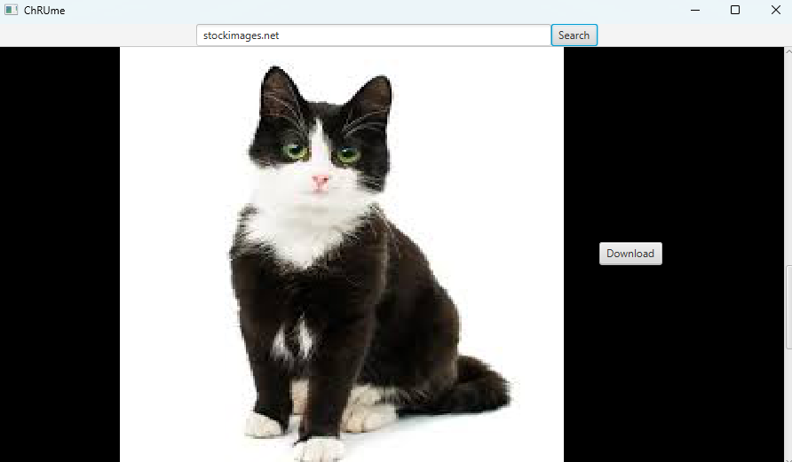

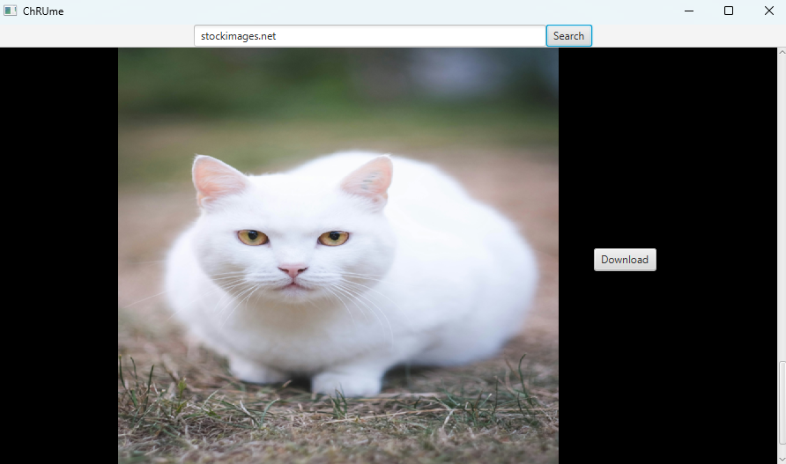

***Figure 22. The First Image the User sees when going to the Website.***

***Figure 23-25. The Images that Users can see when they scroll down.***

***Figures 22-25. The Images that exist within the stockimages.net Website.***

This website has a few main components, those are the **Images** (**cat-image1.jpg**, **cat-image2.jpg**, **cat-image3.jpeg**, **cat-image4.jpeg**) and the **Download buttons** corresponding to each image.

When the user first opens this website, they will be greeted with only some of the images within the website, the rest of the images will be under the other images, which the user can only access or see by **scrolling down** the website.

When the user presses a **download button**, a **TextInputDialog** will appear, prompting the user for the name of the image file.

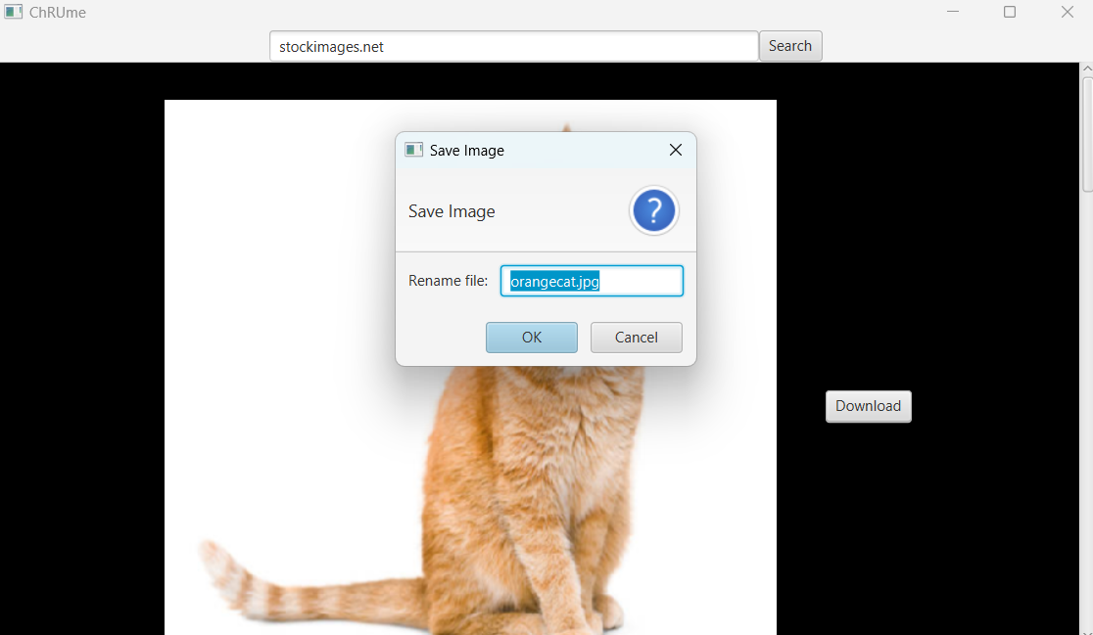

***Figure 26. Prompts the User for the Image File Name***

The default text within the **TextInputDialog** will be the title of each image ending with the **.jpg extension**, here is a list of the title for each image,

* + - **orangecat.jpg** (**cat-image1.jpg**)
    - **graycat.jpg** (**cat-image2.jpg**)
    - **blackcat.jpg** (**cat-image3.jpeg**)
    - **graycat.jpg** (**cat-image4.jpeg**)

The user is allowed to change this file name. However, the **file name** to be saved has to satisfy three conditions: **Alphanumeric (not including the .jpg extension)**, **Unique**, and **ends with the .jpg extension**.

If the given image file name is **not** **alphanumeric**, then provide a warning message,



***Figure 27. Alert for a File Name that is non-Alphanumeric***

If the given image file name is **not unique**, then provide a warning message,



***Figure 28. Alert for a File Name that is not Unique***

If the given image file does not end with the **.jpg extension**, then provide one automatically as the name of the image file.

Once done, create a new **shortcut for the image file** in the **home page**, having the image content as the shortcut icon and the image file name as the shortcut title (has to end with the **.jpg extension**).

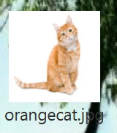

***Figure 29. Example of an Image File Shortcut***

1. **Text File Application**

This application is a derivation of the **Notepad application**. An instance of this application can be opened by clicking a text file shortcut.



***Figure 30. Example of a Text File Shortcut***

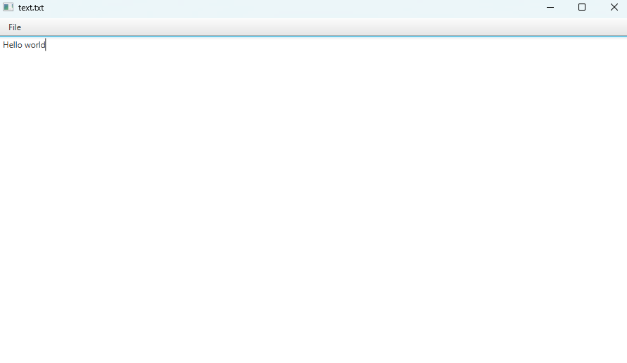

***Figure 31. Example of a Text File Application***

***Components:***

* **ImageView** for the shortcut icon (**notepad-icon.png**)
* **Label** for the shortcut title/name
* **MenuBar** for the menus on the application
* **Menu** for the **File** menu on the application
* **MenuItem** for the **Save** option on the application
* **TextArea** for the content of the application

***Description:***

* When a **Text File shortcut** is clicked, then an instance of a **Text File application** corresponding to the shortcut will appear.
* User is allowed to open as many instances of the same **Text File application** as they please without consequences.
* Unlike the **Notepad application**, the title of the **Text File application** is the name of the text file or the title of the shortcut. An instance of the **Text File application** will also have a body of text readily appear already when instantiated, this body of text corresponds to the last time this **Text File application** is saved, whether through creation or editing.
* User is allowed type and/or edit the body of texts within the contents of the **Text File application.**
* The **File menu**, when pressed, will reveal a **Save** **MenuItem**, which the user can save their edited text file using it.

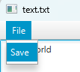

***Figure 32. The File Menu and Save MenuItem***

* + When a user saves a text file, it will update content of the text file in the database of all text files that exists within this instance of the program running. If the user edits the text file and then saves the file, then closes the instance of the text file, when the user reopens that same text file, then the content will be the same as the body of text the user recently updated the text file to.

1. **Photo Editor Application**

An instance of this application can be opened by clicking an image file shortcut.



***Figure 33. Example of an Image File Shortcut***

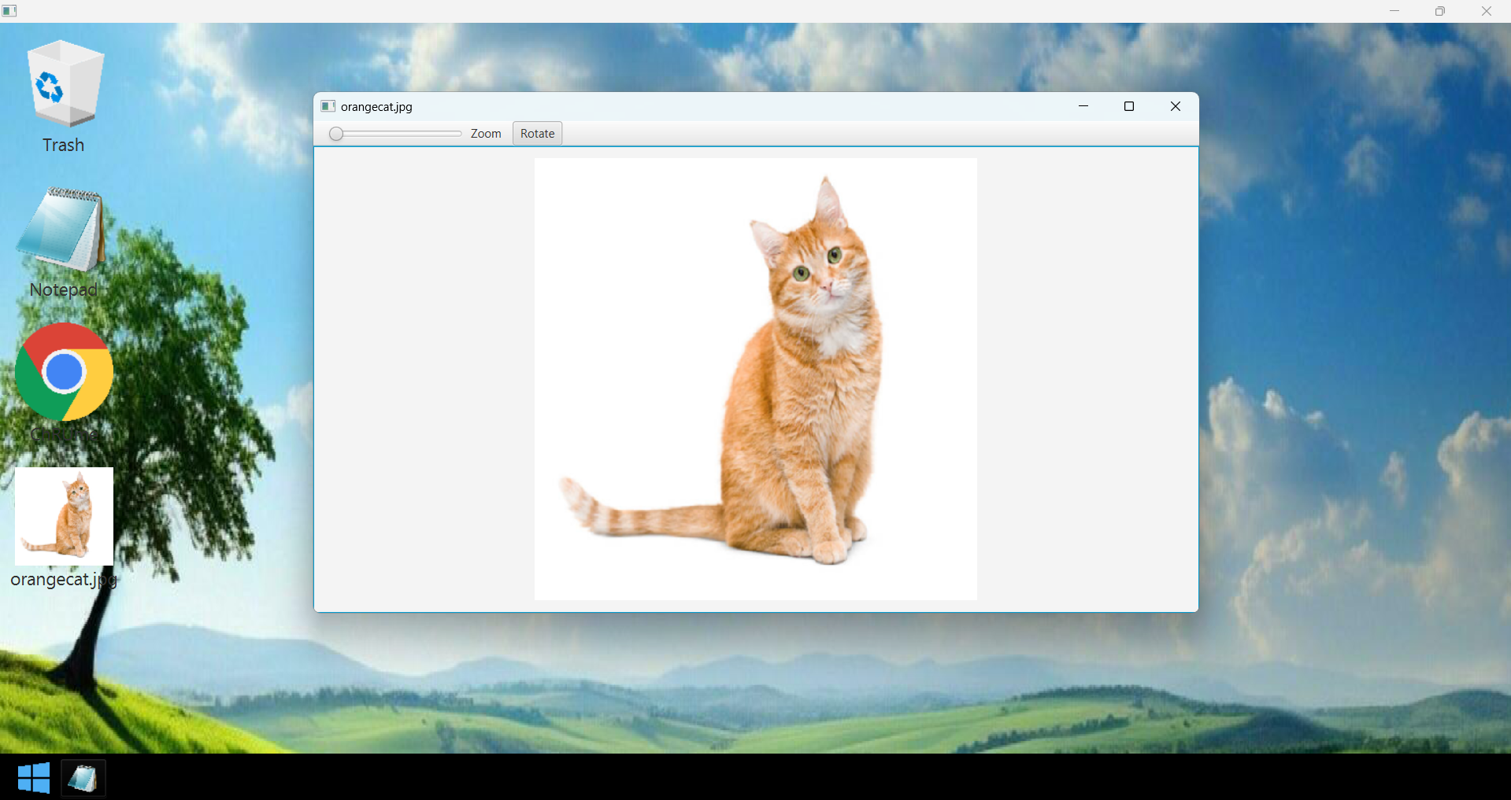

***Figure 34. Example of a Photo Editor Application***

***Components:***

* **ImageView** for the shortcut icon (**in accordance to the file image**)
* **Label** for the shortcut title/name
* **MenuBar** for the menus on the application
* **Menu** for the **Zoom** menu and the **Rotate** menu on the application
* **Slider** for the **Zoom** function on the application
* **ImageView** for the image on the application

***Description:***

* When an **Image File shortcut** is clicked, then an instance of a **Photo Editor application** corresponding to the shortcut will appear.
* User is allowed to open as many instances of the same **Photo Editor application** as they please without consequences.
* The title of the application would be the same as the title of the image file or shortcut of the image file.
* When the **zoom slider** changes values, the image at the center of the application will also zoom in accordance to the slider.

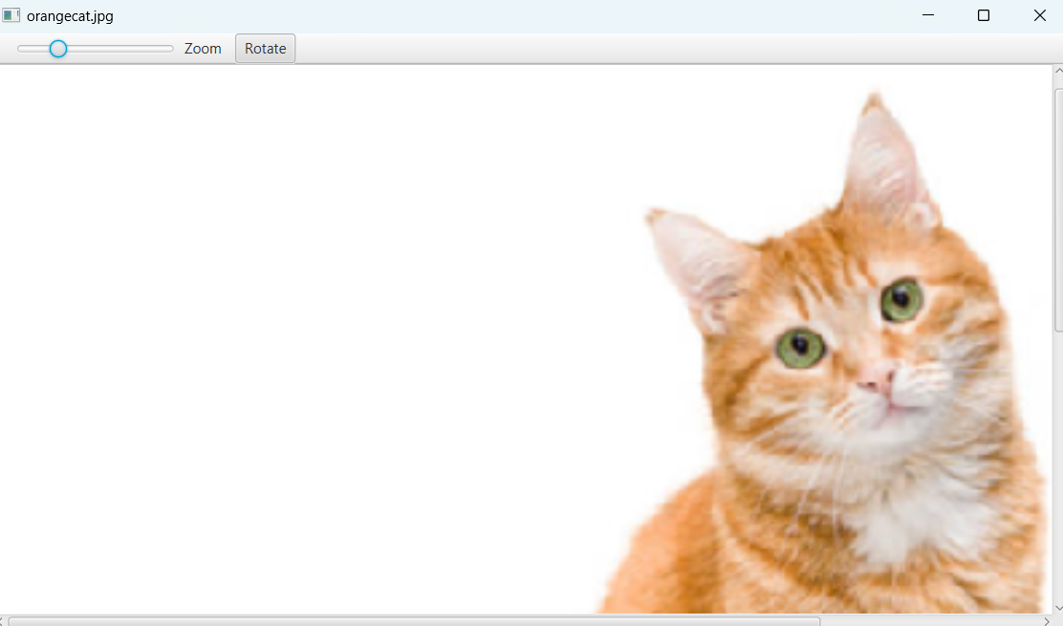

***Figure 35. Image being Zoomed in the Photo Editor Application***

User can also see other parts of the image that are not zoomed in when the slider was initially moved.

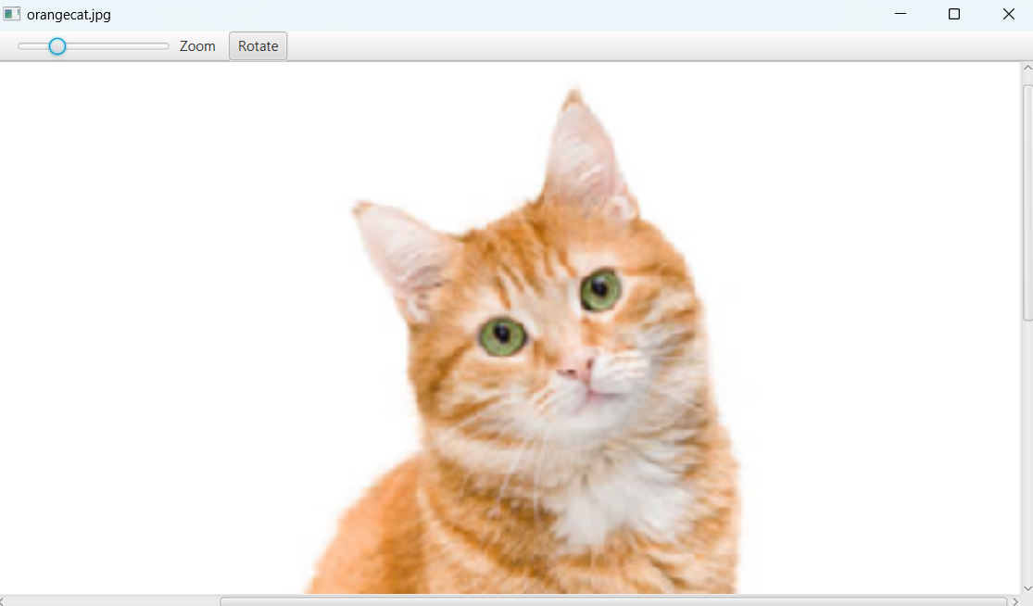

***Figure 36. User can scroll left-right and up-down to see hidden parts of the image***

* When the rotate menu is selected, the image will rotate 90 degrees from the current orientation.

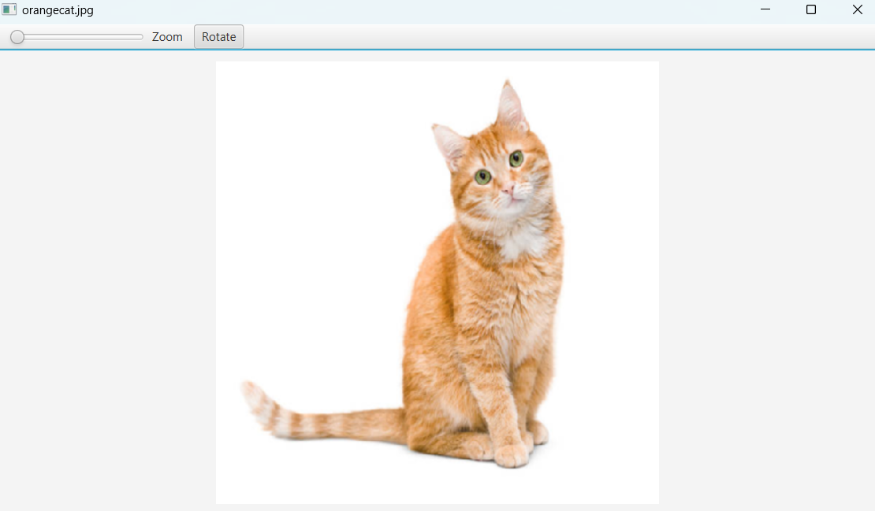

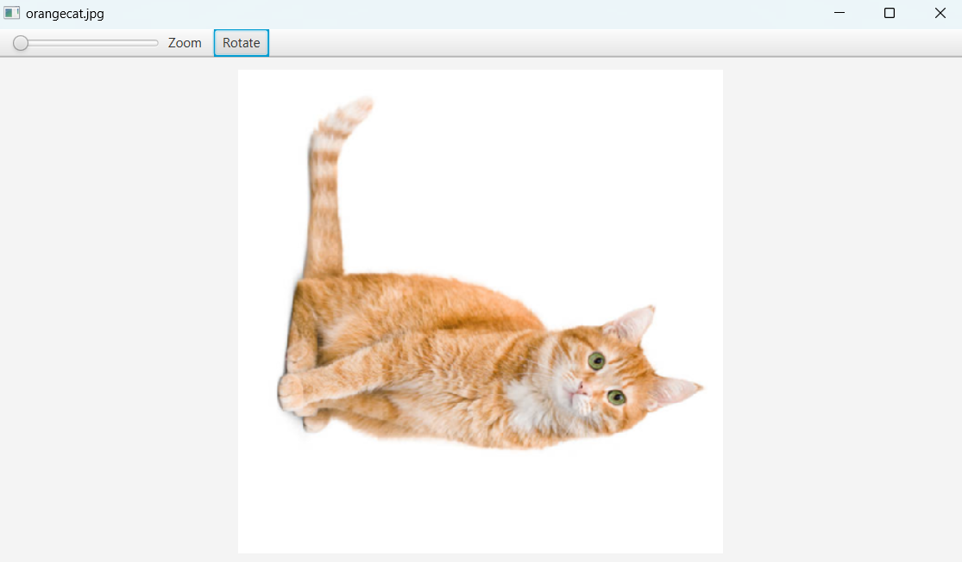

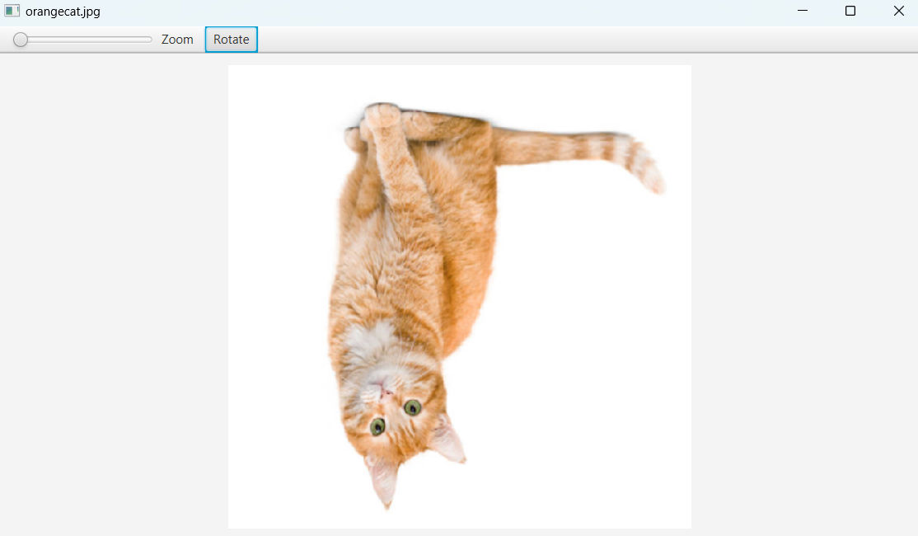

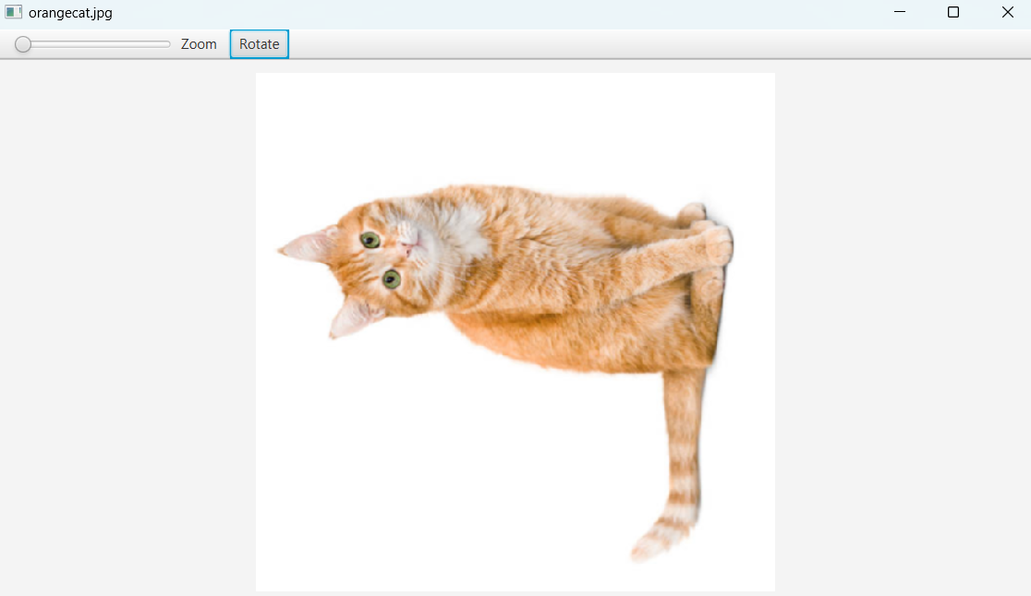

***Figure 37-40. The Image at the Center of the Photo Editor Rotating 90 Degrees every time the Rotate Menu is pressed.***